

Student Development Club System

Supervised by:
Dr. Hany Al-Gaithi

Done by:
- Mohammed Khaled Al-Sanabani
- Abdullah Esam Al-Aswani
- Wegdan Abdulkarem Lutf Al-Hagi
- Al-Hassan Zabarah

- Description why our system is required :

The institute currently lacks a student management system, causing difficulties in the following areas: firstly, record keeping: manually maintaining student records is time-consuming and prone to errors. Secondly, enrollment process: a manual enrollment process is slow and can lead to mistakes in student information. Thirdly, report generation: generating reports such as marks, and transcripts is labor-intensive and may be prone to errors. Fourthly, courses : manually tracking courses such as name of course, hours, and description for the course.
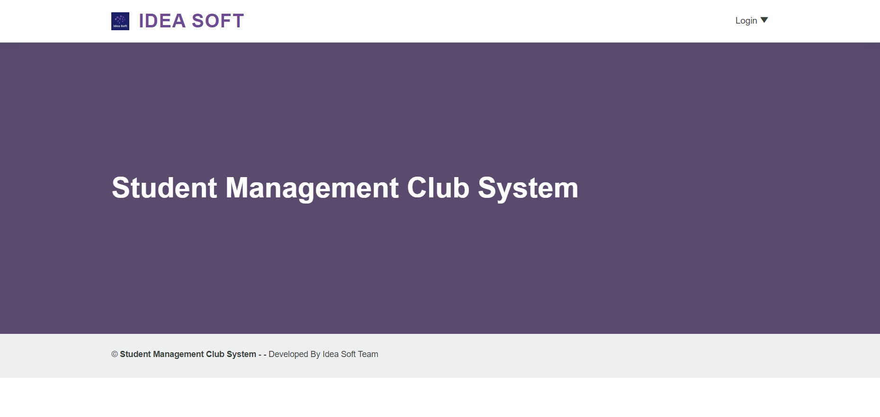

- Login Screen :
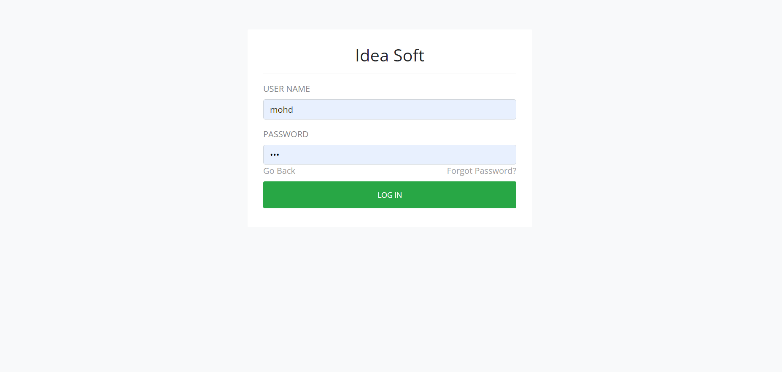

- Dashboard :

This screen after the admin login to the system which contains the Admin panel that contains specific cards in the center of the screen, and menu at the left of the system.
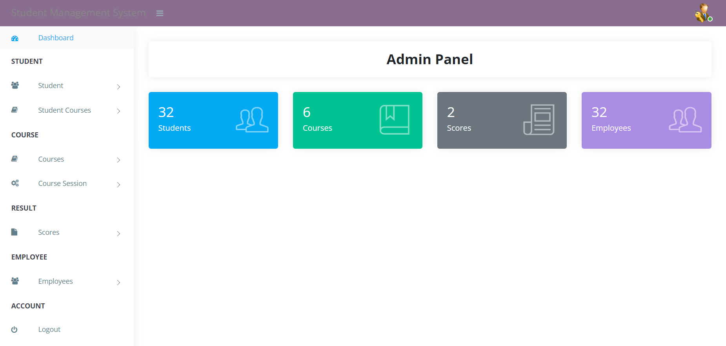

  - Admin panel :

3.1.1 Student card
This screen contains student card where you click and the system reply with students list that are inserted. Beside this, you can search about any specifically student you want. Also, you can modify and delete through it.

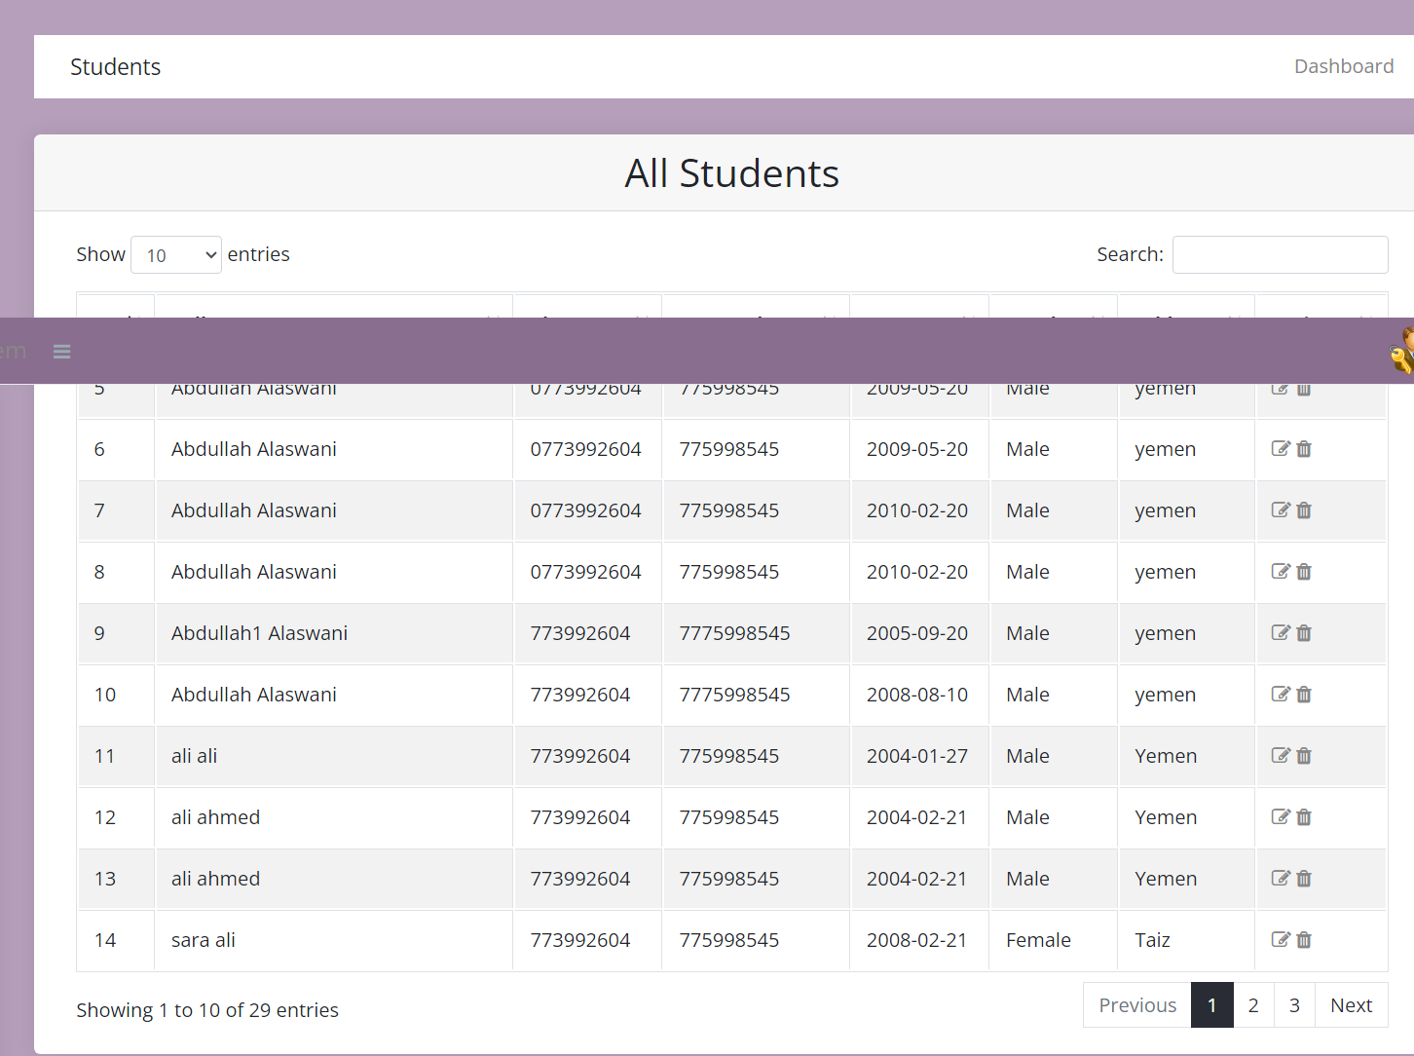

3.1.2 Course card

This show you list of courses that are enrolled in the system and available in the institute . Also you can modify and delete through it.
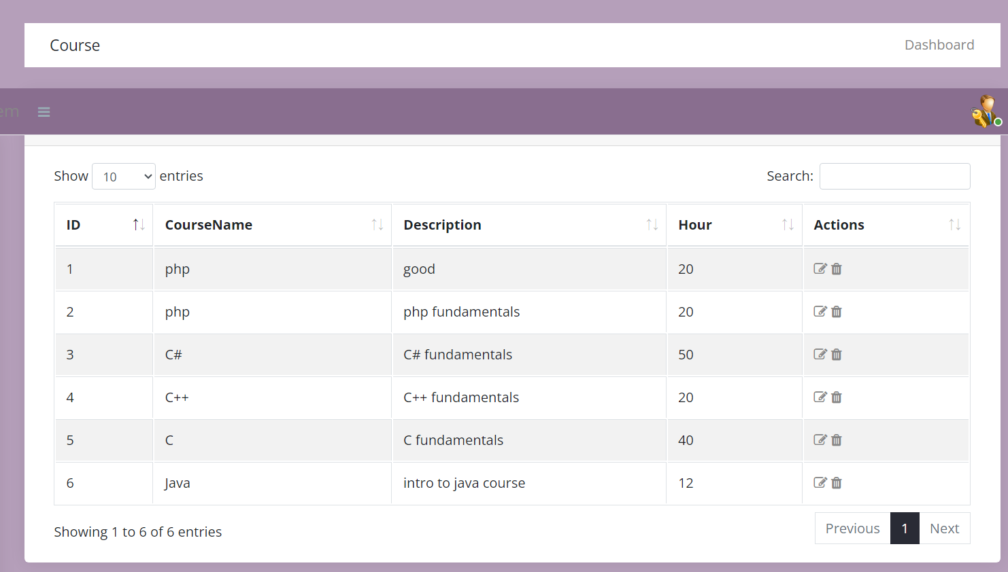

3.1.3 Scores card :
This screen shows you the score of the students with course they studied and get the score for it. Also you can modify and delete through it.
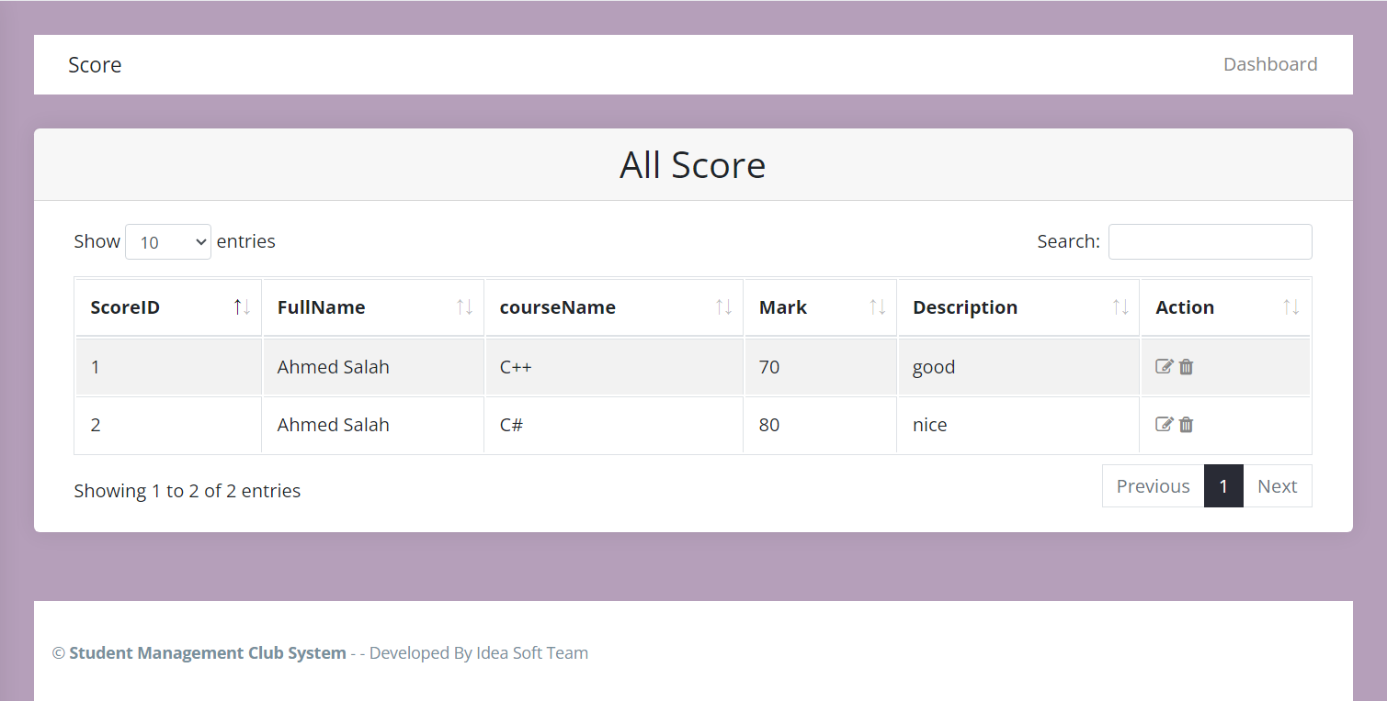

- .1.4 Employees card

This card contains all the employees who are employed in the institute. Also you modify and delete through it.
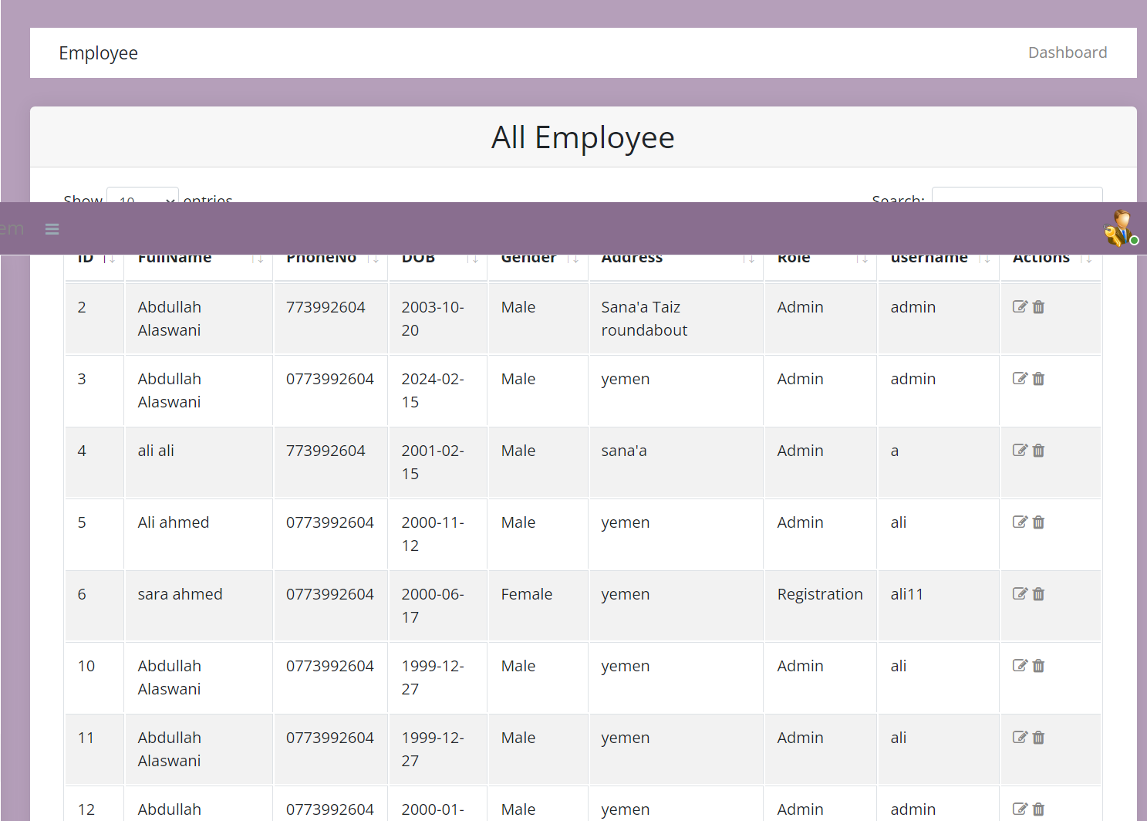

3.2 Left menu

This left menu contain all the parts we analyses-ed previously, which serve three department ( Admin, Registration, and Control ), with sub-menu to each one.

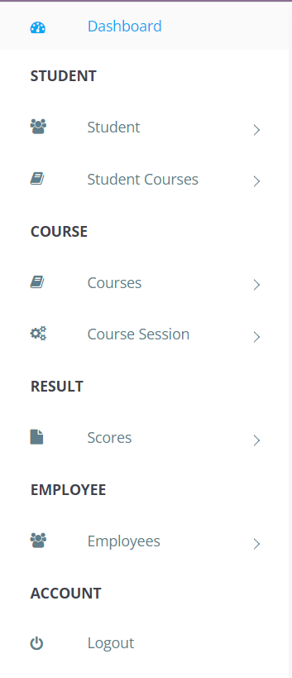

3.2.1 Student

This part contain two menu ( Student , Student course ) .

3.2.1.1 Student menu
This menu contains two sub-menu ( Add student, view student ).
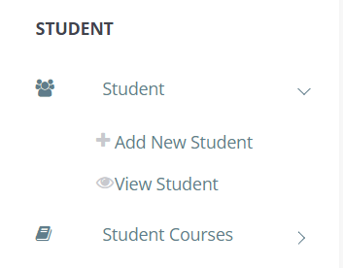
3.2.1.1.1 Add Student
This screen where you can add new student with specific details ( first name, last name, date of birth, phone number, parent, address, gender)
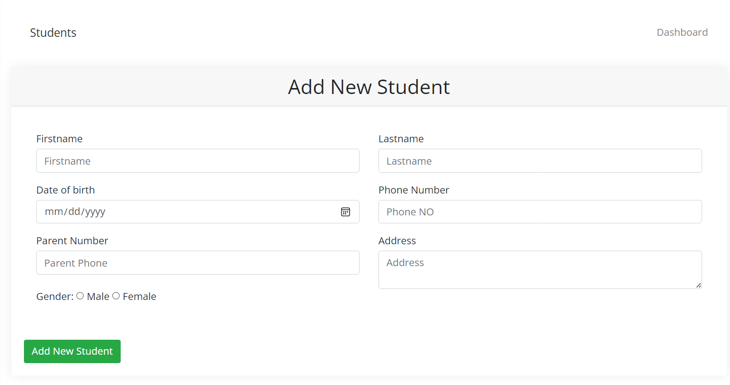

3.2.1.1.1.2 View Student :
This sub-menu where you can see the lists of students, after this you can modify and delete any specific students you want,
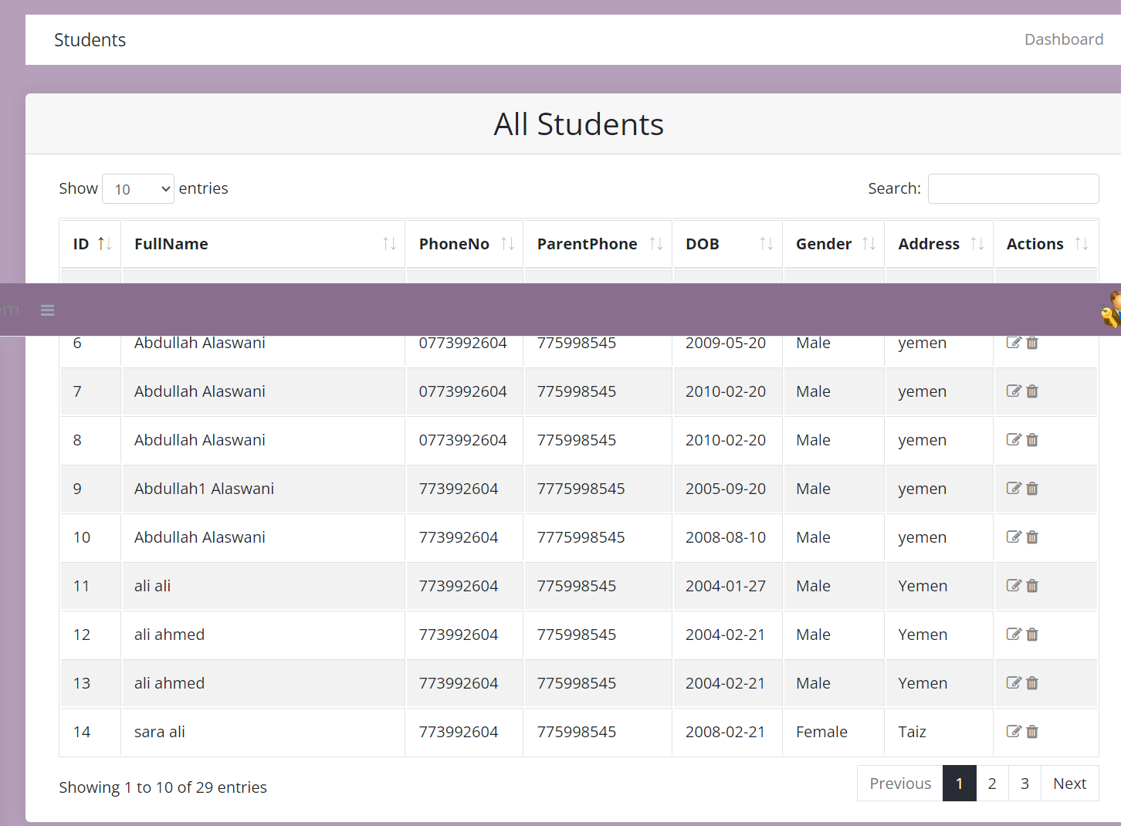

3.2.1.2 Student course menu

This menu contains two sub-menus ( add course for student, view courses of students ).
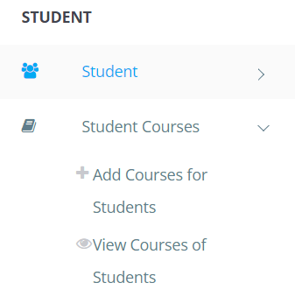

3.2.1.2.1 Add courses for students :

This screen where cant enroll any student to specific course available in the system with specifying the session.
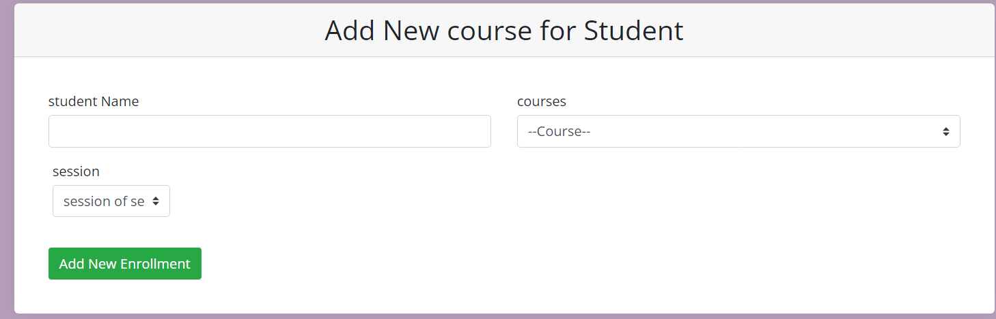

3.2.1.2.2 View courses of student

This screen where you can view the time of session of courses with the students who are in, and show the starting date and ending date

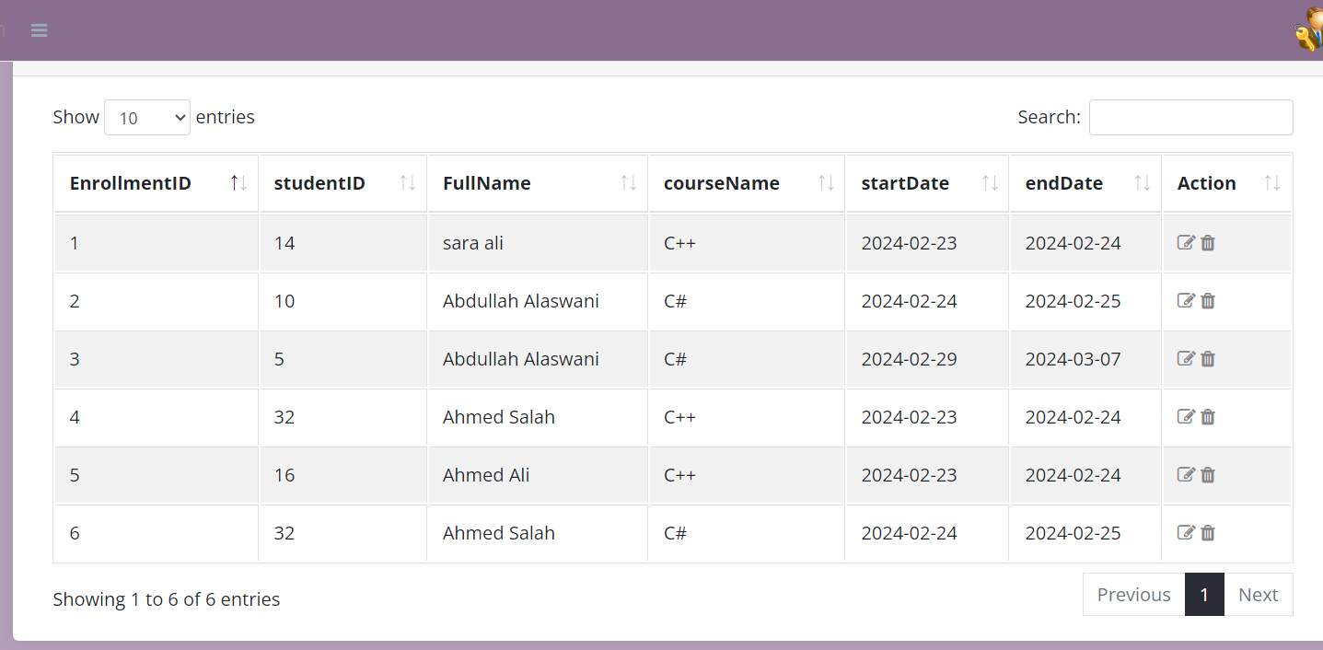

3.2.2 Courses

This menu which contains ( add course menu, course session ).

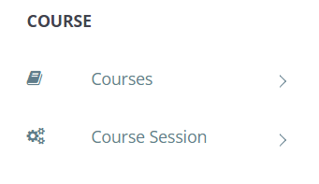

3.2.2.1 Courses menu :

This menu contain two sub-menu ( Add courses, View courses )
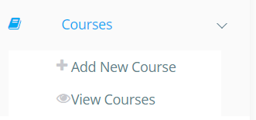

3.2.2.1.1 Add new course

This screen where you can add new courses ( Course name, Description, Hours).
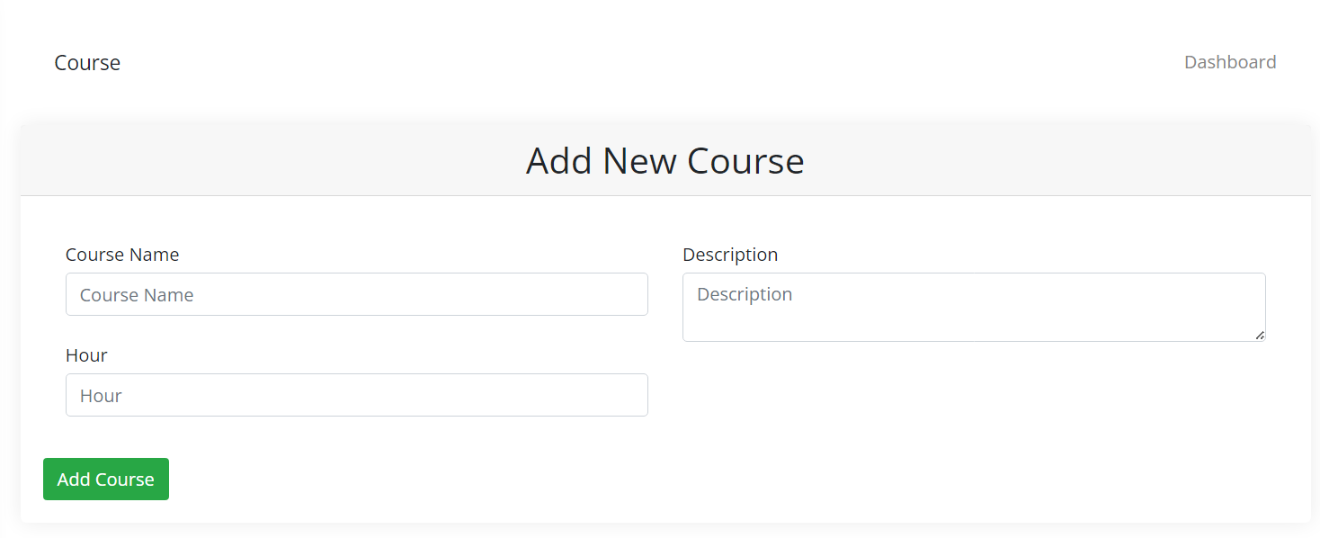

3.2.2.1.2 View courses :
This screen where you can view the courses and you can modify and delete through it any specific course you want .

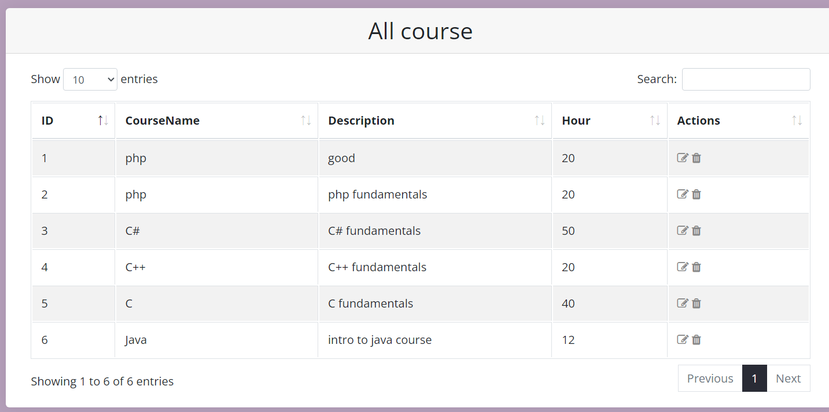

3.2.2.2 Courses session :
This contain two sub-menu ( Add course session, view course sessions ).

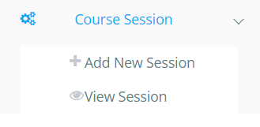

3.2.2.2.1 Add courses session :

This where you can determine session to specific course by determining ( course name, starting date, ending date )
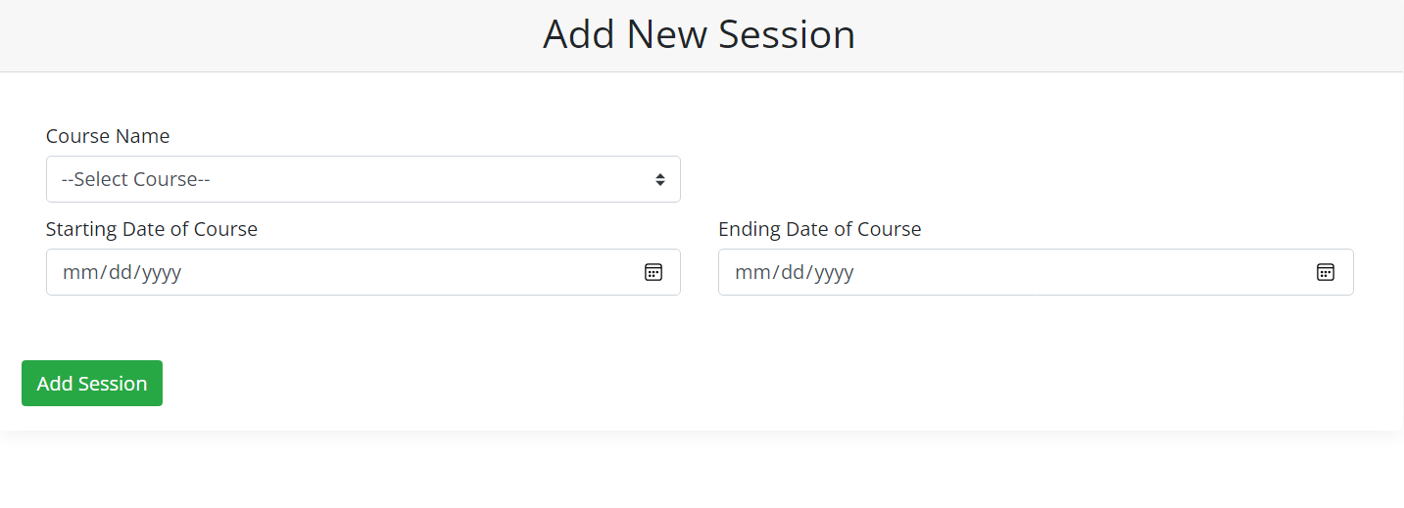

3.2.2.2.2 View session :

This screen where you can view available sessions for specific course .
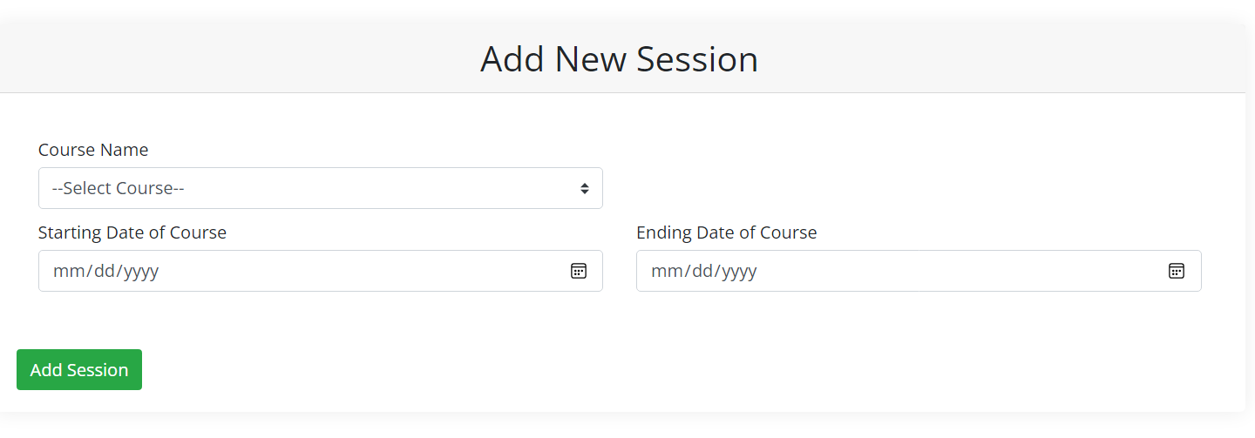

3.2.3 Result
This parts contains two menus ( Add score, View score )
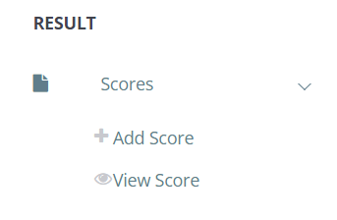
3.2.3.1 Add score :

1This screen you can add score to specific student with the specific course the student toke by adding the student name with his course and add the score he/ she deserves.

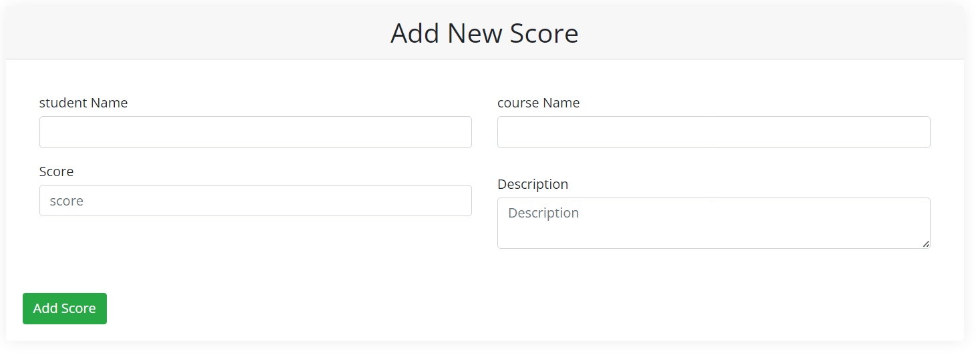

3.2.3.1 View score :
This sub-menu shows the scores of student, and you can modify and delete throught it.
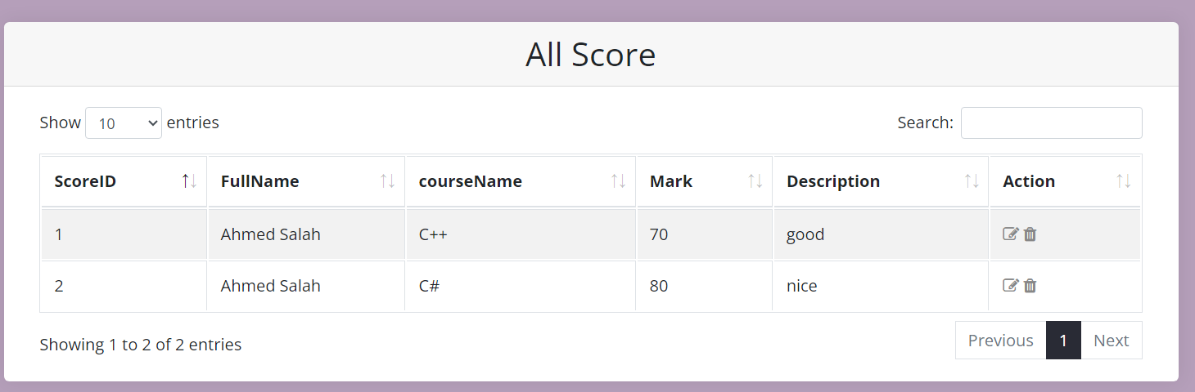

3.2.4 Employees :

This part contains two menus ( Add employees, View employees ).

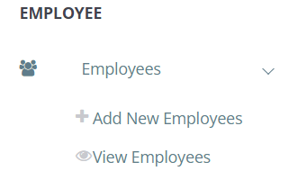

3.2.4.1 Add employees :

This screen where you can add new employees by details shown down and determining the roll.

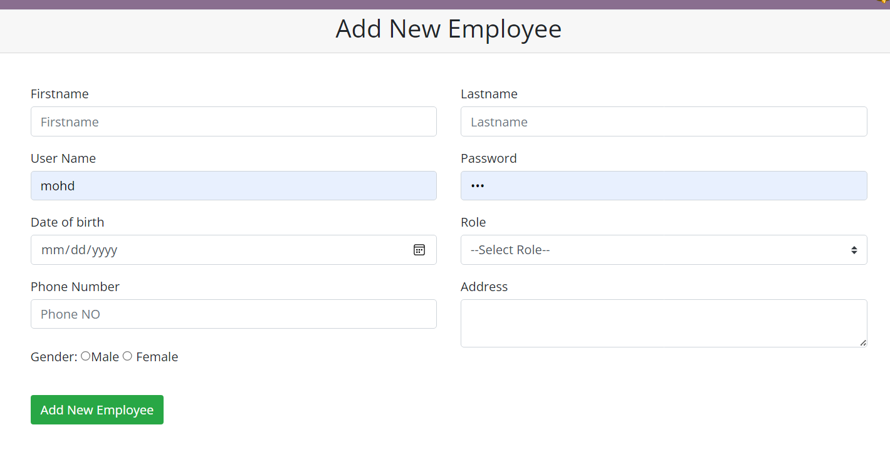

3.2.4.2 View employees :

This screen where you can view lists of employees, and you can modify and delete through it.

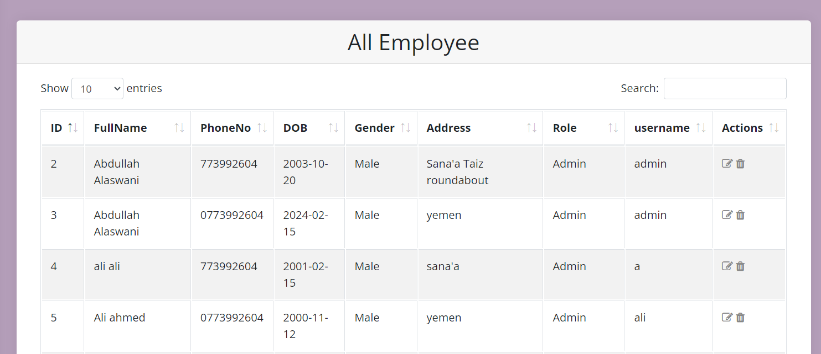

3.2.5 Logout :

Here where the owner of the account can logout.

